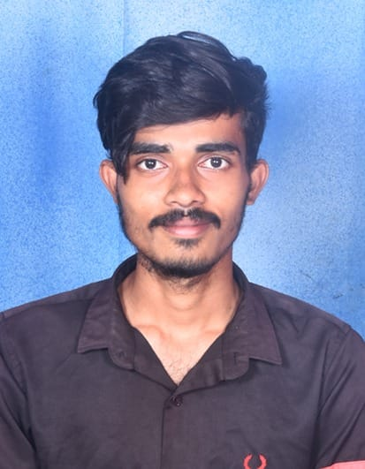

## PERSONAL INFO

 +91 6304298822

 [pvengalrao4@gmail.com](mailto:pvengalrao4@gmail.com)

<https://www.linkedin.com/in/vengalarao-pasala>

# SKILLS

### HTML CSS

  

### JAVASCRIPT



#### **PYTHON**

Pasala Vengalarao

#### B. TECH (COMPUTER ENGINEERING)

**"To keep learning and enhance my skills in a dynamic and stable workspace."**

**ACADEMIC PROJECT**

**PROJECT TITTLE:** IOT Data Sharing: A Proxy Re-Encryption Approach with Blockchain-Based Security

**Description:**

* Developed a robust IoT data sharing system leveraging cutting-edge technologies.
* Implemented Proxy Re-Encryption to ensure secure data sharing without compromising original content.
* Created a scalable solution to accommodate a growing number of IoT devices and users.
* Collaborated with cryptography experts, blockchain developers, and IoT specialists to achieve system synergy.
* Proven ability to innovate and adapt in a rapidly evolving technological landscape.
* Showcased problem-solving skills, attention to detail, and dedication to data security.
* Front-end: JSP, HTML, JAVA
* Back-end: My SQL
* For Sever-Side script: JSP
* Role - Team-member (I managed All My tasks and support my team)
* Front End Dev. (I have done all the coding required for front end)

  

**Web Development in Django**

## EDUCATION

### B. Tech (Computer Engineering) AUGUST 2019 - MAY 2023

   

**MY SQL**



# HOBBIES

**Playing Chess and puzzles. Reading about Spirituality.**

* R S R Engineering College, Kavali, Nellore(dist)

- 6.64/10.0 (JNTUA)

**INTER** JUNE 2017 - MAY 2019

* Sri Chaitanya junior College, Kavali

- 75% (BIEAP)

**S.S.C.** JULY 2016 - MAY 2017

* Sri Rama Krishna Public School, Kakinada

- 80% (BSEAP)

## STRENGTHS

Logical Thinking

Enthusiastic and open to learn new ideas

Quick learner and ability to work under pressure